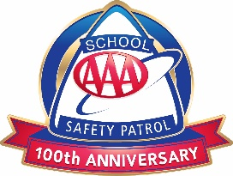

Dear Parents and Guardians,

The AAA School Safety Patrol program will be active at __________ Elementary School! Students chosen for the program will be assigned posts throughout the school to ensure the safety of our students during morning arrival and afternoon dismissal. By implementing this program, we are offering students the opportunity to:
- demonstrate responsibility,
- display leadership skills,
- take an active part in keeping our school environment safe.

Students were given an overview of the program by ___________ and those who expressed an interest were given an application. These applications must be completed and returned to __________ no later than __________. In order for your child to be considered for the AAA School Safety Patrol program they must submit the application with your signature and a teacher recommendation.

Candidates will be selected with the following criteria:
- ability to follow rules,
- good attendance record,
- respect for classmates and desire to help others, and
- teacher recommendation/parent permission.

The AAA School Safety Patrol advisor will be __________. He/she will be responsible for the day-to-day activities such as scheduling, problem-solving and overseeing the patrollers at their post. We will be choosing approximately __________ students to serve this school year and they will be positioned in the following locations throughout the school:
- List all patrol post locations

As parents, we will need your support for this exciting new peer leadership program and look forward to launching the AAA School Safety Patrol program at __________ Elementary!

Sincerely,

Were you a member of the AAA School Safety Patrol? Share your story with us!

